Anton and Polyhedrons
time limit per test
2 seconds
memory limit per test
256 megabytes
input
standard input
output
standard output
Anton's favourite geometric figures are regular polyhedrons. Note that there are five kinds of regular polyhedrons:
- Tetrahedron. Tetrahedron has 4 triangular faces.
- Cube. Cube has 6 square faces.
- Octahedron. Octahedron has 8 triangular faces.
- Dodecahedron. Dodecahedron has 12 pentagonal faces.
- Icosahedron. Icosahedron has 20 triangular faces.
All five kinds of polyhedrons are shown on the picture below:
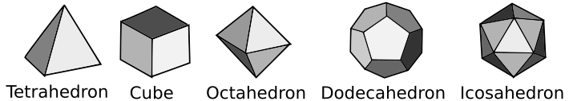
Anton has a collection of n polyhedrons. One day he decided to know, how many faces his polyhedrons have in total. Help Anton and find this number!
Input
The first line of the input contains a single integer n (1 ≤ n ≤ 200 000) — the number of polyhedrons in Anton's collection.
Each of the following n lines of the input contains a string si — the name of the i-th polyhedron in Anton's collection. The string can look like this:
- "Tetrahedron" (without quotes), if the i-th polyhedron in Anton's collection is a tetrahedron.
- "Cube" (without quotes), if the i-th polyhedron in Anton's collection is a cube.
- "Octahedron" (without quotes), if the i-th polyhedron in Anton's collection is an octahedron.
- "Dodecahedron" (without quotes), if the i-th polyhedron in Anton's collection is a dodecahedron.
- "Icosahedron" (without quotes), if the i-th polyhedron in Anton's collection is an icosahedron.
Output
Output one number — the total number of faces in all the polyhedrons in Anton's collection.
Examples
input
Copy
4
Icosahedron
Cube
Tetrahedron
Dodecahedron
output
Copy
42
input
Copy
3
Dodecahedron
Octahedron
Octahedron
output
Copy
28
Note
In the first sample Anton has one icosahedron, one cube, one tetrahedron and one dodecahedron. Icosahedron has 20 faces, cube has 6 faces, tetrahedron has 4 faces and dodecahedron has 12 faces. In total, they have 20 + 6 + 4 + 12 = 42 faces.

